# Overview

In this lab, we will work with the Brackets editor to develop a basic home page. Each student's page will be linked in a master "index" page that will serve as our class information page.

I have created a page for myself so you can see what the final product will look like. This page is available at http://people.hopewebdesign.net/. (Click on the link to my name to see the page).

As you can see from this page, we'll be creating a web page that contains the following information about ourselves:

* Some basic information, like where we're from, where we went to school, and our intended major
* A list of links to some of our favorite activities and music groups
* Some pictures of places we've been & places we'd like to visit

**In all cases, if you'd rather not provide the actual information requested on the page, feel free to make something up.**

# Getting Started

1. Double-click on the **This PC** icon on your computer’s desktop.
2. In the left portion of the window that comes up, right-click on the Documents folder.
3. Choose New – Folder from the pop-up menu.
4. Change the default name from New Folder to csci150 and press **Enter** (all lower case, no spaces).

We’ll usually create a new folder for each lab or other assignment we work on:

1. **Left-click** on the csci150folder you just created (in the left part of the Windows Explorer window)
2. In the **right** portion of the Windows Explorer window, **right-click** and choose New—Folder.
3. Type Lab1and press **Enter** to change the name of the folder.

## Copying the starting files for the lab

1. TODO In Windows Explorer, **left-click** on the course (W:) from the list of drives under the heading *This PC* on the left side of the window.
2. Double-click on the each of the folders named CS, 150, and Lab1.
3. Press CTRL – A to select all of the files and folders in the Lab1 folder.
4. Press CTRL – C to copy the files in the Lab1 folder to your computer’s clipboard.
5. Left-click on Documents on the left side of the Windows Explorer window.
6. Double-click on the csci150folder you created previously.
7. Double-click on the Lab1folder.
8. Press CTRL – Vto copy the starting files into the Lab1 folder.

# Using Brackets to edit HTML

Brackets is a program we will use to edit our HTML and CSS files for this course. It is one of several options available for this type of work; one advantage of Brackets is that it is free and can run on both Mac and Windows computers.

1. Click on the Start button in the lower left corner of the screen.
2. Type **Brackets** into the search box.
3. Choose the option **Brackets**.
4. Once Brackets opens, choose File – Open Folder from the Brackets menu.
5. Navigate to Documents\csci150\Lab1.
6. Click the *Select Folder* button.

Choosing a folder causes a list of the existing files and folders to be shown in the *sidebar* in the left portion of the Brackets window. [1]

You should see several folders, one for each student in the beta-test, and a file named index.html.This file is a special file that a web browser will display if no file is specified when you enter an address into the address box. For example, entering the URL www.hope.edu into the address box will cause the contents of the index.html file associated with the www.hope.edu site to be displayed.

Let’s take a look at the file associated with Prof. McFall to get a feeling for HTML.

1. Find the folder named mcfallin the left sidebar.
2. Click the triangle next to mcfallto expand the folder’s contents.
3. Double-click on the file mcfall.htmlto open the file in the Brackets editor.[2]
4. At the top of the file, you’ll see the text <head>. We’ll get into the contents of this element later in the lab; for now, we’ll **collapse**it to get it out of our way, by clicking on the downward pointing triangle next to the line number for the line containing this element.  
   
5. Click the lightning bolt icon  on the right hand edge of the Brackets window. This button starts Brackets’ *Live Preview* feature.   
     
   A browser window will open; position the browser window on the right half of your display by clicking on it, and then pressing the key combination Windows – Right Arrow (the Windows key looks like  and is located in the bottom left corner of the keyboard). Then select the Brackets windows when Windows shows you miniature versions of each window, which will move Brackets to the left half of the display.
6. Click somewhere inside the <body> element and watch what happens in the browser window (you should see the contents of the window briefly highlighted with a blue background, and then change to have a blue border around them). The <body> element’s contents are what is displayed in the browser window.
7. Click in at least one of the <p>, <img>, and <h1> elements, to see how they are displayed in the browser.

In general, a web page consists of elements contained within < > and </ > pairs[3] (called **tags**) and text within those tags. Taken together, the tags and their content are called **elements**. The starting tag for each element can have **attributes**, which give more information about that element. For example, the <img> element has an attribute named *src* which tells the browser where to find the contents of the image.

Now that you’ve gotten a feel for what the contents of a web page look like, we’ll create a file where you can put information about yourself.

1. Ensure Brackets' sidebar is visible, and then locate the folder that has been created for you.
2. Right-click on your folder and choose the menu option *New File*.
3. A new file appears within your folder, and Brackets allows you to immediately change its name. Name the file **lastname.html**, replacing *lastname* with your actual last name. Be sure it is all lower case, with no spaces or punctuation.  
     
   The reason the name of the file, its case and its extension matter is that I've **already** created links in the index.html page to each of your pages; these links point to files using this particular naming convention.
4. A blank file should open in the Brackets editor. Enter the following contents into the document (Brackets will insert the ending tag for each element after you enter the > symbol for starting tag):

<html>

<head>

<title>About me</title>

</head>

<body>

</body>

</html>

1. Replace the word *me* inside of the title element with your first name (use whatever you prefer to be called).
2. Insert a new line between the <body> and </body> tags, and type the following text into the document, replacing the elements in *italics* with the appropriate information:

<body>

<p>

<strong>Name</strong>: *Your name*

</p>

<p>

<strong>Hometown</strong>: *Your hometown*

</p>

<p>

<strong>High School</strong>: *Your High School*,   
 class of *Your graduation year*

</p>

</body>

1. Press CTRL – S to save the document (do this frequently to ensure you don’t lose work if something goes wrong!)

## Publishing your work

All the edits we've made have been on the **local** version of the file; Brackets operates by editing files on your computer, so that you don't work directly on files visible to the whole world. We'll now publish your files to the web site people.hopewebdesign.net, using a program named **FileZilla** to transfer the files from your computer to the people.hopewebdesign.net server.

1. Click on the Start button (lower left corner of the keyboard) and type **Filezilla**. Once the application has been located, press **Enter** or click on it to start it.
2. Choose File – Site Manager from the FileZilla menu.
3. Click on the *New Site* button. Type **CSCI 150 People Site** and press Enter to replace the name *New Site* shown on the left portion of the Site Manager window. The Site Manager window should now look like this (I've cut out a bit in the middle):

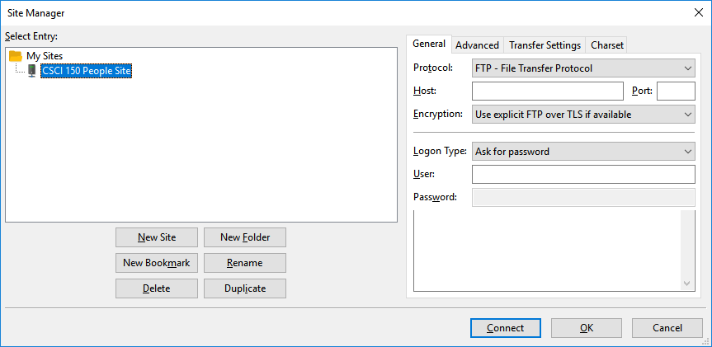

1. Enter the following information:   
   **Host**: ftp.hopewebdesign.net  
   **Port**: 21  
   **Encryption**: Only use plain FTP (insecure)  
   **Logon Type**: Ask for password  
   **User**: people@hopewebdesign.net
2. Click the button labeled *Connect*. When prompted, enter the password **people.CS150** and then click OK.  
     
   If prompted whether to save passwords, choose *No* since you are on a shared computer. If you set up FileZilla on your own computer, you may decide to save passwords to make it more convenient.  
     
   It **is** OK to check the box asking whether you want to *Remember password until FileZilla is closed*. Just remember to close FileZilla at the end of the lab.
3. Check the box labeled *Always trust certificate in future sessions* and then click *OK* if the window with the title *Unknown certificate* is shown.  
     
   This information is used to verify that the computer you're connecting to is in fact the one you intend; often the "fingerprints" will be published somewhere you trust, and then you can compare what's sent when connecting to the known "fingerprints." We'll just assume that nothing nefarious is going on.

FileZilla's main window uses a "two-pane" layout, with the files on your computer (the "local site") on the left, and the files on the people.hopewebdesign.net server (the "remote site") on the right.

Transferring files from one place to the other is accomplished by dragging them from the source (usually the local site) to the destination (using the remote site). We'll now do that to copy the file you've been editing to the server.

1. Click on the Documents folder on the left side of the window, under the label *Local Site*.  
     
   You should see the contents the Documents folder listed below the *Local Site* label, including the csci150 folder you created earlier.
2. Double click on the folder csci150 to open it, and then open the Lab1 folder by double clicking on it.  
     
   This causes the contents of the folder to be displayed in the bottom portion of the left pane. You should see a listing of folders, one per student, along with the file index.html.
3. In the bottom portion of the local (left) pane, double click on your folder.  
     
   This opens the folder and shows the listing of files in the folder. You should see a file named lastname.html, with **lastname** replaced with your actual last name.
4. Find your folder on the right (remote) side of the FileZilla window and click on it.  
     
   Since we haven't yet copied anything to the server, this folder will be empty. The folder exists on the server because I created each of them before the test began.
5. In the local (left) pane, right-click on lastname.html and choose Upload. This copies the file from your computer to the folder you currently have open in the remote (people.hopewebdesign.net) website.

Once you have copied the file to the server, you should be able to see your page, either by going to the page http://people.hopewebdesign.net/ and clicking on the link to your page, or by typing the URL in directly as http://people.hopewebdesign.net/first.last/last.htmlreplacing *first.last* with your 1Hope information and *last* with your last name.

Keep FileZilla open; we'll use it later to upload a new version of your file after you've made a few more changes.

## Adding links to some sites

Now you'll add some more details about yourself, including links to sites other than our own.

1. Between the </p> for your high school and the </body> ending tag, add an <h1> element with the contents **Hobbies**:

</p>

<h1>Hobbies</h1>

</body>

1. Under the *Hobbies* heading, write a paragraph or two about what you like to do when you have free time. Each paragraph should be contained within a <p> </p> pair:

<h1>Hobbies</h1>

<p>

One thing I like to do is …

</p>

<p>

Another hobby of mine is …

</p>

</body>

Next, you’ll create a **bulleted list** of links to other web sites having to do with your hobbies. You can check the instructor’s page for an example (go to people.hopewebdesign.net and then click the link for the instructor's page).

1. Get started by adding the basic structure for a bulleted list. Note the 'l' is the **letter** 'l', not the **number** 1.

<ul>

<li>Contents of first bullet</li>

<li>Contents of second bullet</li>

…

<li>Contents of last bullet</li>

</ul>

1. Add links within the bullets. First, put the appropriate element structure in place – the <a> element is used to create links in HTML:

<ul>

<li>I like to eat ice cream at <a href="">Captain Sundae</a>. </li>

1. Locate the site you want to link to, using a web browser if necessary. Then copy the URL from your browser’s address bar by clicking in the address bar, ensuring all the text is selected, and pressing CTRL – C.
2. Paste the URL as the contents of the *href* attribute, in between the double quotes, as shown below:

<a href="http://www.captainsundae.net/">Captain Sundae</a>.

1. Repeat to add links for each of your bullets.
2. Below the bulleted list (after the </ul> ending tag), add another <h1> element with the contents **Favorite Musical Artists**, and create a bulleted list of links to the home pages for two or three of your favorite musicians or groups.   
     
   The '1' in <h1> is the **number** one, not the **letter** 'l'
3. Press CTRL – S to save your page.
4. Switch back to FileZilla.
5. Make sure you have H:\csci150\Lab1\first.last open in the bottom portion of the left pane (replace first.last with your actual first and last names)
6. Make sure you've opened your folder in the right pane.
7. Drag the file lastname.html from the left pane to the right pane to copy it to the server. You can see a video at http://shortlinks.hope.edu/webdesign-lab1-filezilla2
8. Ensure that it looks as you would expect by visiting people.hopewebdesign.net and following the link to your page.

**An important point**: web browsers often *cache*, or keep a temporary local copy, of pages you visit in order to speed up the process of downloading them again in the future. Sometimes, clicking the reload button  in the browser will not get the most recent version of the file from the web server. Holding down the Shift key while clicking the reload button will generally cause the browser to get the most recent version.

## Adding pictures to your favorite vacation spots

Next we'll spice up our document with a few images.

1. Create a new <h1> element after your list of favorite musical artists with the text **Places I've been or would like to go**.
2. Enter <p> elements for each of the places you want to include pictures for. For example, my list at this point looks like this:

<h1>Places I've been or would like to go</h1>

<p>El Tejar, Chimaltenango, Guatemala</p>

<p>Lugano, Switzerland</p>

<p>Yunnan Province, China</p>

<p>Istanbul, Turkey</p>

<p>Silver Lake, Michigan</p>

<p>Disney World, Orlando Florida</p>

1. Position the cursor **after** the ending paragraph tag </p> text of your first location (*El Tejar, Chimaltenango, Guatemala* in my case).
2. Press **Enter** to add a new line.
3. Find a picture. One place you can do this and be relatively sure you aren't violating any copyright held by the photographer is the Wikipedia Commons, located at http://commons.wikimedia.org/wiki/Main_page. Use the search box at the top right corner of the page to help you find what you're looking for.

Once you've found the image you’re looking for (be sure you’ve clicked on the desired image so you’re seeing just the image (it will look a lot like a PDF file preview within Gmail).

1. Click the  button in the bottom right corner of the window to share the image.
2. Ensure the *Embed* “tab” is selected.
3. Select either Small, Medium, or Large from the drop-down list at the bottom.
4. Click in the box containing the HTML code for the image. This should select all of the text.
5. Press CTRL – C to copy the text.
6. Go back to Brackets, and press CTRL – V to paste the text. It might now look something like this

<h1>Places I've been or would like to go</h1>

<p>Lugano, Switzerland</p>

<p><a href="https://commons.wikimedia.org/wiki/File:24MonteBre.jpg#/media/File:24MonteBre.jpg"><img src="https://upload.wikimedia.org/wikipedia/commons/5/5c/24MonteBre.jpg" alt="24MonteBre.jpg" height="145" width="193"></a><br>"<a href="https://commons.wikimedia.org/wiki/File:24MonteBre.jpg#/media/File:24MonteBre.jpg">24MonteBre</a>" by <a href="//commons.wikimedia.org/w/index.php?title=User:MarkusMark&amp;action=edit&amp;redlink=1" class="new" title="User:MarkusMark (page does not exist)">MarkusMark</a> - <span class="int-own-work" lang="en">Own work</span>. Licensed under <a href="http://creativecommons.org/licenses/by-sa/3.0" title="Creative Commons Attribution-Share Alike 3.0">CC BY-SA 3.0</a> via <a href="//commons.wikimedia.org/wiki/">Wikimedia Commons</a>.</p>

When you've found images for each location, publish your page to the site using FileZilla; refer to the instructions on page 5 if you need a refresher on how to do this.

# Some other things to try

**Set a background color for your page**. To do this, add a style attribute to the <body> element. **Be careful not to put a space between the 'b' in rgb and the '('**.

<body style="background-color: rgb(255,0,0);">

Then, right-click on the 255 in the style attribute, choose *Quick Edit*, and use the color picker to select the desired color. The *rgb* colorrepresentation uses a particular combination of red, green and blue to represent a color; we’ll talk about this in more detail in future labs.

**Change the text color for your page**.To do this, add a second part to the style attribute:

<body style="background: rgb(255,0,0); color: rgb(255,255,255)">

You can again use the Quick Edit method to open a color picker to choose a color.

Your links won’t change color when you do this; we’ll learn how to control the color of links in a subsequent lab.

**Add some video to your page**.First, find a video on YouTube about one of your hobbies or vacation spots. Once you’ve found a video, click *Share* and then *Embed*, as shown below:  
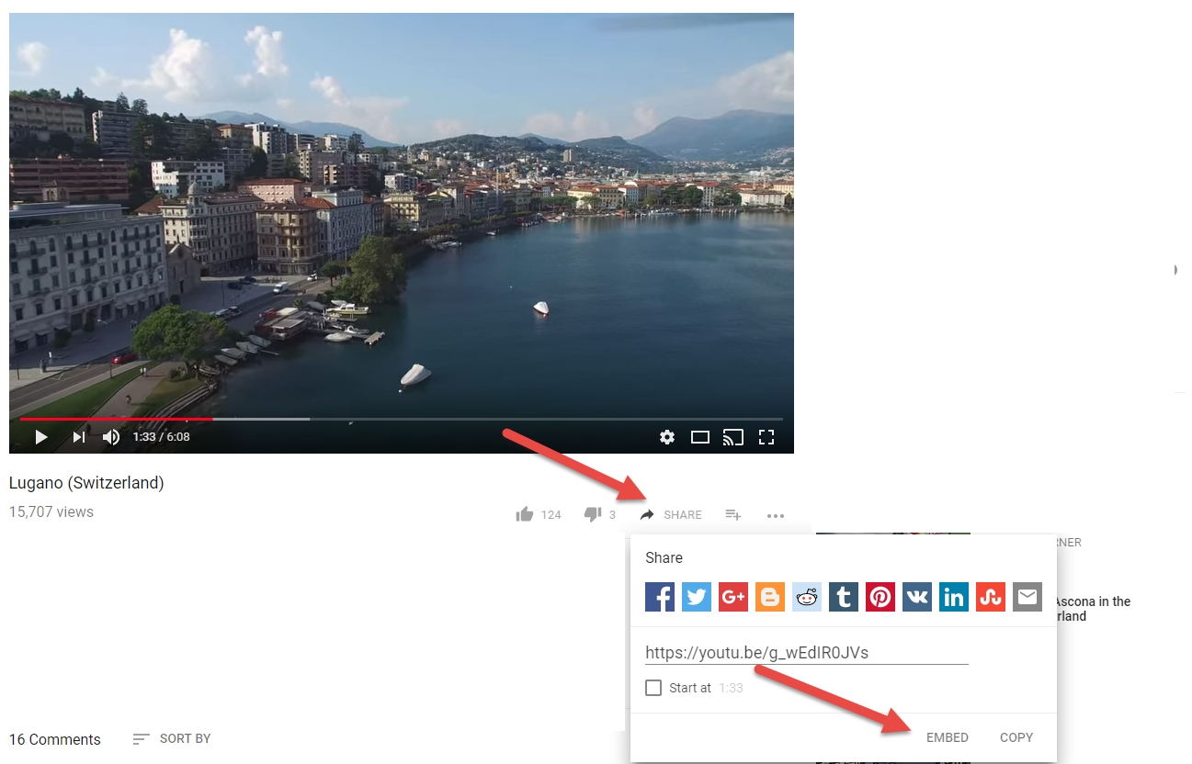

Follow these steps to copy/paste the video into your page:

* Click the COPY link in the bottom right corner of the Embed Video window.
* Switch to Brackets.
* Find the spot where you wish to embed the video (inside the <body> element, but not inside any other tags).
* Press CTRL – V to paste the block of HTML into the document.

You should now see the video in the live preview window.

When you are done, save your document (CTRL – S) and then use FileZilla to upload it. You don't need to turn anything in via Moodle; I will collect the lab by downloading a copy of people.hopewebdesign.net at the beginning of next week's lab.

1. You can use View – No Distractions or press CTRL – SHIFT – 2 to maximize the amount of space used to display the document's contents. Repeat to bring back the folder view.
2. Double-clicking opens the file and keeps it in the list of “Working Files” at the top of the sidebar. Clicking once will open the file, but once you access a different file you won’t be able to get back to the file you single-clicked on as easily.
3. Some elements are “empty” elements, meaning they don’t have any content. These elements, such as the **img** element, combine the starting and ending tag like this: <img/>.